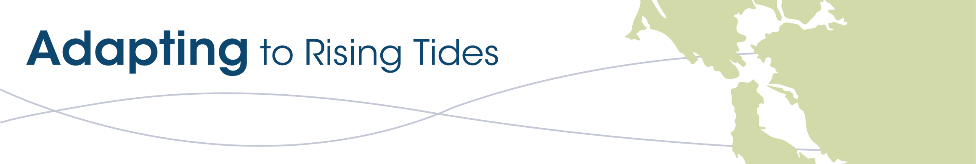
CONTRA COSTA ADAPTING TO RISING TIDES PROJECT
WORKING GROUP MEETING #8
Wednesday, November 16, 2016

MEETING NOTES

Welcome and Objectives: Wendy reminded the group that the last step in our process is implementation and monitoring.

Updates and News Items:
- 5th BCDC Commission Workshop on Dec 1st on Implementing Priority Actions on Advancing SLR Planning
- BCDC has finished the Policies for a Rising Bay Report
- ABAG is hosting a workshop on how to successfully apply for federal funding, with an emphasis on FEMA $ (Dana)
- Contra Costa County workshops on Community Choice Energy (Jody)

Presentation by Wendy Summarizing our Contra Costa ART Process and Accomplishments.
- Key outcomes to date include:
  - Built working group
  - Developed broad resilience goals
  - Prepared robust vulnerability assessment
  - Improved understanding of how flooding may impact the 4 sustainability frames
  - Created locally refined SLR maps and shoreline analyses
  - Determined detailed adaptation responses
  - Made the case for taking action together individually and together.
  - ART Project report will be ready soon and many components are already posted to the working group page.
- Recap of what we learned on adaptation responses for 30 asset categories
  - Library of actions you can review at any time
  - Information, governance, structural challenges (unique and shared challenges)
  - Approaches to addressing the 6 Key Planning Issues: Cross-cutting issues that bring together geographies and assets that we looked at throughout the whole project
  - Last time we sticker voted on actions to guide this final meeting.
  - The voting revealed 4 overarching themes:
    - Resilient transport system
    - Integrated shoreline management
    - Targeted education and outreach
    - Emergency and hazard mitigation plans: these plans need to look at future hazards and be responsive to the specific needs of the communities that they are meant to serve
- Now we move into the Implement and Monitor Step. We will work on:
  - Some ready to go actions
  - Some need for additional assessment before we know exactly what steps should be taken next
  - In this step, we apply Implementation Pathways Tools which enables us to:
    - Come to agreement on what we really want to do to implement these actions
    - Who will lead and who will partner
    - What steps will be needed
    - We’ll leave this conference room with many “to do” items
    - Actions reflect what you prioritized at the open house and overarching themes that came out of the plan step. Cross-cutting issues that resonate for many of the asset categories. These are actions that will get the county and everyone moving towards adaptation.
    - Double check: Do the actions help meet resilience goals and all frames of sustainability?
    - Develop concise statement of why we should take this action and how.

Implementation Pathways Poster and Mad-Lib Exercise and Report Back. Working group members completed Implementation Pathway posters on four actions (selected through sticker voting during meeting #7):
- Action #1 - Develop and disseminate guidance to business and industry on the best practices for reducing the potential impacts of flooding and sea level rise on their facilities and the services and systems they rely on.
- Action #2 - Create a public-private shoreline working group tasked with developing a plan to fund and implement integrated shoreline solutions to reduce flood risk.
- Action #3 - Develop a county-wide program to monitor, maintain, and repair (as feasible) at risk shorelines most in need of intervention.
- Action #4 - Establish a public-private partnership to better understand the consequences of flooding on commercial and industrial supply chains, employee access to job sites and the regional transportation networks goods and commuters rely on.
The implementation pathways exercise focused on identifying actors and information, timelines for implementation, and feasibility for each action as well as checking in on whether or not the action would achieve resilience goals. Summaries of poster results can be found on the working group page. The madlib exercise focused on creating an elevator pitch for work on each action. The group provided the following feedback at the close of the exercise:
- Our 4 actions are so interrelated that we don’t need 4 distinct groups implementing them.
- 1st step should be presenting to Board of Supervisors to tell them that they need to delegate responsibilities and funding to get the ball rolling.
- We don’t need to reinvent the wheel. There are already existing Industry Groups to engage.
- Because a lot of the adaptation actions are dependent on funding, BCDC should be reviewing the funding guidelines and streamlining the permitting process.
- Railroad and refineries will be greatly impacted. We need to figure out their concerns and incorporate those concerns. That will give us a lot of weight in our effort in terms of federal action in Washington, especially in terms of economics, job creation.
- Regional support is essential. BCDC needs to stay engaged. Eastern shoreline needs to be incorporated. It is a gap. BCDC recognizes that it is a critical information gap on our end and we are looking to fill it.
- Contra Costa County is doing their Hazard Mitigation Plan update, but Hercules is not included due to lack of capacity. As a small jurisdiction, need to think about the biggest pieces of the puzzle to incorporate immediately.
- BCDC explained that we’re well positioned to take up the eastern county in a robust way—we’re looking for funding to do this.
- BCDC and our ART Help Desk are always available to provide support.

